Multi-Purpose Building

University of Calgary
Alberta, Canada
Short Circuit, Coordination, and Arc Flash Study Report

Revision: 1 Date: 3/04/2024

Authorization
 | Name | Date | Signature
Developed By
Reviewed By

Table of Contents
Contents
Table of Contents 2
1. Executive Summary 1
2. Foreword 2
2.1. Purpose of the study 2
2.2. Scope of studies 2
2.3. Methodology 2
2.4. System Description 2
2.5. Basis and assumptions 3
2.6. Input Data 3
2.6.1. Generator Impedance 3
2.6.2. Transformer Impedance 4
2.6.3. Conductors 4
3. Short Circuit Study 6
4. Protective Device Coordination 7
4.1. Main Panel (LV Panel) Protection and 8
5. Arc Flash Study 13
Appendix A: Definitions and Concepts from NFPA 70E‐2004 14
Appendix B: Single Line Diagrams with Short Circuit and Arc Flash Energy Levels 25
Appendix C: Data from the Short Circuit Study 26
Appendix D: Time Current Characteristics (TCC) Curve 27

Executive Summary
The purpose of this study is to establish the protective device settings and evaluate the arc flash hazard at Multi-Purpose Building located at Alberta, Canada. The power flow analysis examined the network under steady normal operation and offered useful data for organizing upcoming expansions and figuring out how best to run current systems.
The short circuit study determined that the interrupting capacities of the equipment at this station are adequate, i.e. they exceed the largest possible short circuit current experienced by a given equipment.
The coordination study established protective device settings that would provide adequate selectivity between devices at calculated fault levels, minimizing the project's overall annoyance trips and confining the issue to the particular subcircuit. Ultimately, the incident energy at the location was ascertained by the arc flash study, which is crucial information for guaranteeing the security of workers who handle or are near electrical equipment.

Foreword

Purpose of the study
Short circuit, protection coordination and arc flash studies were performed for the LV electrical system of this project. The short circuit study is performed to ensure that the electrical equipment has sufficient fault interrupting capability and short circuit withstand capacity. The coordination study examines the proper settings for the protection devices. The Arc Flash study establishes and analyzes arc flash hazards in identified electrical equipment in the site, and if applicable, identifies concerns associated with such hazards.

Scope of studies
This includes [3] 0.208kV panels. Short circuit, coordination, and arc flash results for downstream devices will be studied.

Methodology
The study will be based on current codes, industry standards, practices, and expectations.
- For Component sizing, Voltage drops, active & reactive power measurement:
- Load Flow (by Newton Raphson method- with 99 iterations for convergence were used) and it was performed with the help of ETAP 19.01 Software
- For Short Circuit Study: To find Maximum 3 phase fault, in the Network 3-Phase, LG, LL, & LLG Fault Currents ANSI Standard was used. For protection & coordination& arc flash: A minimum 0.1 sec time difference is adopted used and Reference Standards: NFPA 70 (NEC), IEEE Std 242, IEEE Std 446, IEEE Std C37.91, IEEE Std C37.96 are used.

System Description
This Installation consists of the 25kV Utility grid that feeds the 225KVA, 25kV/0.208KV Distribution Transformer.
This transformer provides power to the whole Project along with the 85kW Generator and the 70 KVA PV plant for the emergency case or loss of power due to unforeseen circumstances.
Transformers along with the generator and the Solar system are connected to the MAIN DB or MAIN LV PANEL rated at 208/120V 60Hz. Which feed further panels LV panel-1 and LV PANEL-2 along with HVAC and Fire pump.
A 11.3kVA UPS is also provided for the critical loads that must not be interrupted in any scenario.
This system is detailed in the Single Line Diagrams in Appendix A

Basis and assumptions
- The Electrical Transient Analyzer Program (ETAP, version 19.01) is used for performing the studies.
- Priority Loads are not listed to some power and lighting loads and are given an uninterrupted power supply.
- Cable lengths are calculated in milestone 3.
- Utility short circuit is assumed to be for 250 MVASC as it is not provided.

Input Data

Generator Impedance

Genset for 85KW (208/120V) was used in the project. Technical information for the Genset units is available in the data sheet along with this report. Typical impedances provided by ETAP were utilized. The impedance values are shown below:

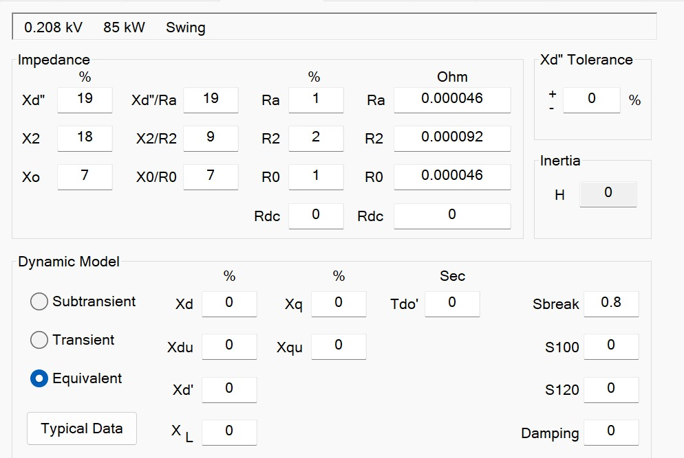

Transformer Impedance
Technical information for the transformers was not available at the time of the studies. Therefore, typical impedances provided by ETAP were utilized. The impedance values are shown below:

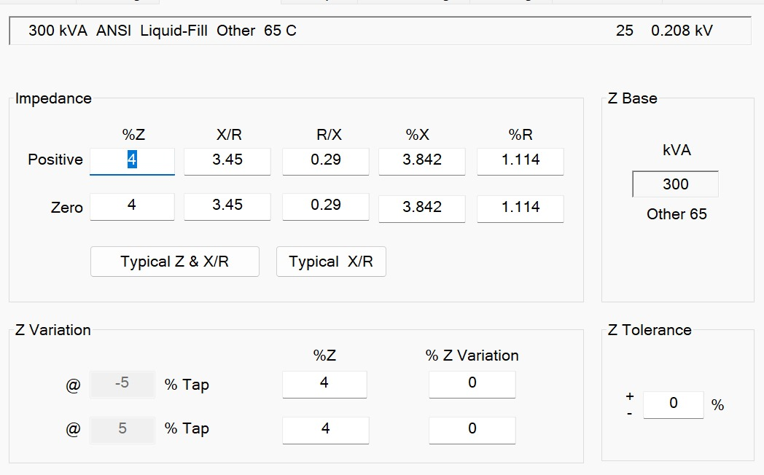

Conductors
Technical information for the conductors was not available at the time of the studies. Therefore, typical impedances provided by ETAP were utilized.

EQUIPMENT DATA SHEETS

The equipment data sheet of all the equipment listed is attached below.

- Generator 85kW
- Distribution panels
- LED downlight 38W & 21W
- LED spotlight 9W
- Transformer (225KVA, 25/0.208KV)
- Uninterruptible power supply 15 kVa
- 350-Watt Solar Panels
- Solar panels Battery 460.8 V, 400 AH
- 70K hybrid Inverter
- External batteries 25KW (UPS)
- Circuit Breakers
- Conduit and fittings
- Fire pump 30 HP

Short Circuit Study
To make sure that the equipment's short circuit rating and the protective devices' interrupting rating are more than the maximum short circuit current that is available, a short circuit analysis was conducted. It was discovered that all equipment had adequate short circuit ratings. Appendix A contains the short circuit values for each bus, and Appendix B has the whole short circuit report. Table 1 summarizes the short circuit levels at each bus. Different types of faults such as three-phase faults, line-to-line faults, and line-to-ground faults can be analyzed.

Through this short circuit analysis, we might be able to select switch gear equipment that is required for protection, such as fuses, circuit breakers, and isolators. It also helps with relay settings that distinguish between full load current and fault current.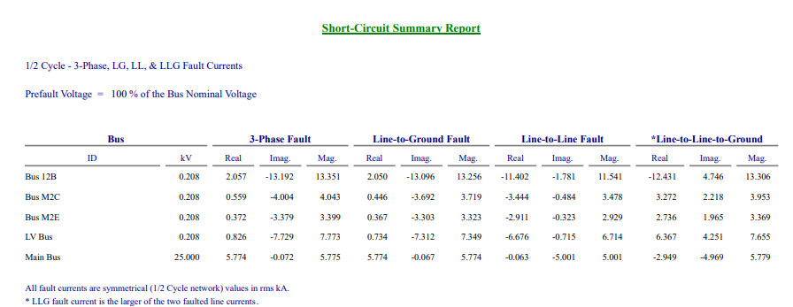
Short circuit levels

Analysis summary:

- The Main Bus that has an Isc 3-phase Fault level of 5.775 Ka.
- Similarly, the M2C LV panel will have a 3-phase fault of 4.043 Ka and the LG fault of 3.719.
- The LV panel M2E will have a 3-phase fault of 3.399 Ka and the LG fault of 3.323.
- The LV bus Panel will have a 3-phase fault of 7.773 Ka and the LG fault of 7.349.
- As per this simulation results, we can clearly see that the Fault level is decreasing in magnitude as we are moving from the utility towards the final loads (DBs).

Protective Device Coordination
The coordination study is performed to determine the appropriate protective device settings to achieve the following objectives:
- Ensure all electrical equipment are adequately protected without exceeding their thermal limits,
- Ensure settings are sensitive enough to detect all faults within the capability of the protective device, and
- Ensure selectivity between protective devices when possible.
In addition to preventing or minimizing equipment damage, a properly coordinated power system will isolate only the faulted portion of the power system, and hence minimize the extent of the outage or also known as tripping.

Main Panel (LV Panel) Protection and
The following time current corves show how the above objectives were achieved.

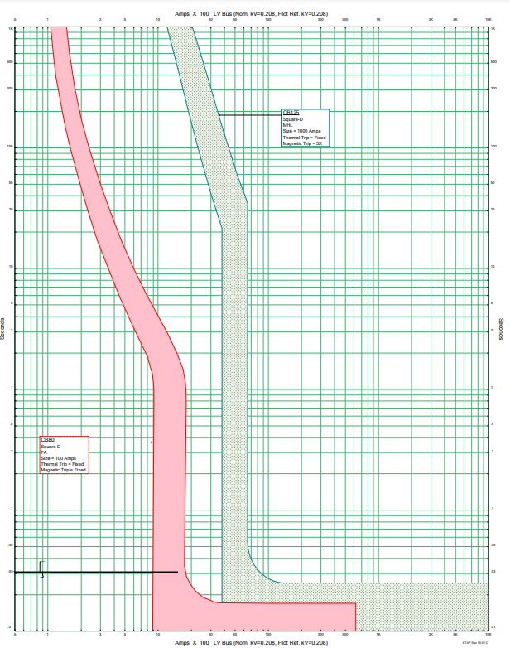

Main Panel (LV Panel) Protection and coordination with M2C Panel (LV Panel)

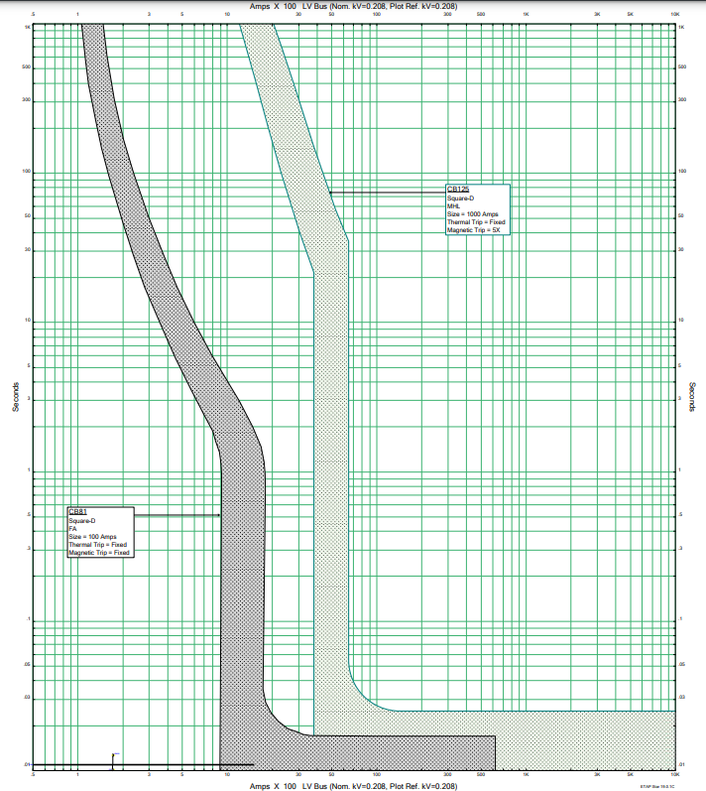

Main Panel (LV Panel) Protection and coordination with M2E Panel (LV Panel)
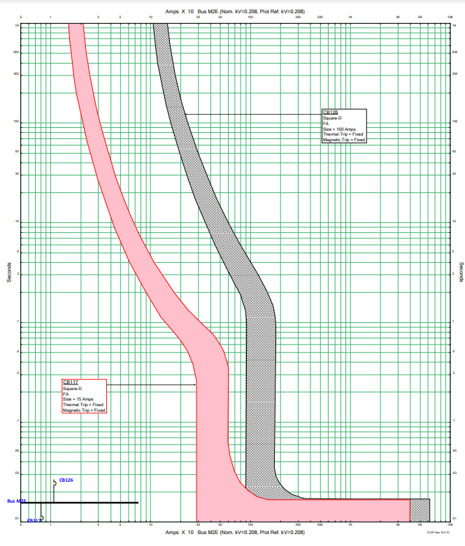

Main Panel (LV Panel) Protection and coordination with M2E Panel (LV Panel)
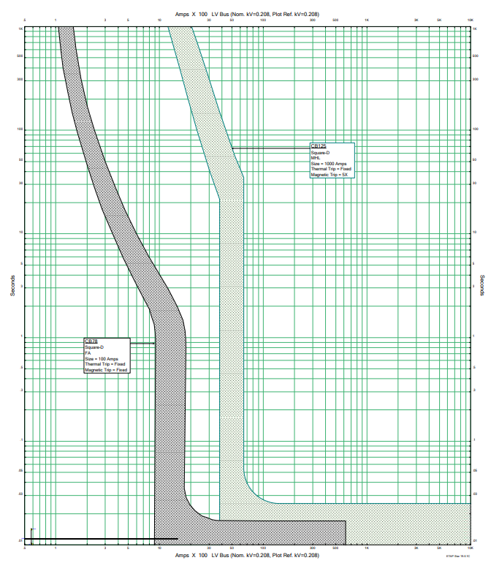

SUMMARY RESULTS

Time current curves and detailed protective device settings are presented in the above example, and we can clearly see a time difference of more than 0.2 sec in each case.
That shows that the discrimination as per IEEE242 has been achieved in all the panels.
Partial or Selective coordination exists between the Some Circuit Breakers, where both incoming are outing are fed from the Same CB frame rate for example the Output M2E Panel & incoming of M2C Panel.

Recommendations and Modifications NEEDED as per IEEE 242.

According to the guideline below, we should have a correct mode of operation, which means that the regular mode, emergency mode, usage of PV modules, percentage of battery storage, and utility should all be clearly specified in our sequence of operation since every mode has a unique coordination and fault current. Inquiring into the client's normal mode of operation, as well as how the generator and PV are used at different times, should be our priority. A P&C study should also be completed in those situations.

Priority loads and UPS usage should be specified as well, whether the UPS will be used continuously or only occasionally in an emergency. This can be explained more during the client meeting.
Which loads such as power or small are essential enough to require a UPS alone since the UPS alone has a capacity of 11.35KW.

When coordination is impossible due to a selectivity issue, it should be done at the stage with the least amount of economic disruption. indicates that it will be isolated or that it shouldn't have an impact on the overall system. However, problems should never arise in the main panels. By using the same circuit breaker for UPS panel (M2A) and feeding the same rating downstream with this clause, we may justify our selective issue.

Arc Flash Study
The short circuit calculations and the Fault Clearing Time (FCT) required by the protective devices are calculated by ETAP. The results are summarized in Table 2.

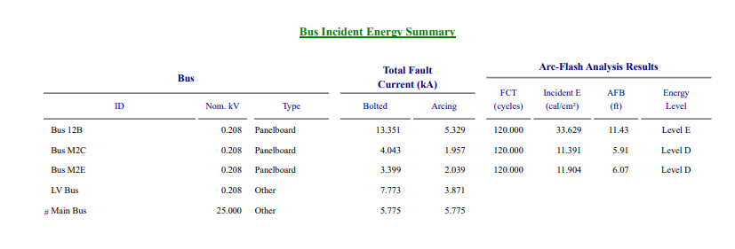
Table 2: Arc flash energy results

Complete arc flash results are available in Appendix E.

Appendix A: Definitions and Concepts from NFPA 70E‐2004

NFPA Standard 70E is a critical reference for the performance of this study. For the benefit of this report’s reader, NFPA’s definitions that are relevant to the study have been re‐iterated as follows:

“Arc Rating: The maximum incident energy resistance demonstrated by a material (or a layered system of materials) prior to break open or at the onset of a second‐degree skin burn. Arc rating is normally expressed in cal/cm².”

“De‐energized: Free from any electrical connection to a source of potential difference and from electrical charge; not having a potential different from that of the earth”
“Electrical Hazard: A dangerous condition such that contact or equipment failure can result in electric shock, arc flash burn, thermal burn, or blast.
FPN: Class 2 power supplies, listed low voltage lighting systems, and similar sources are examples of circuits or systems that are not considered an electrical hazard”

“Electrical Safety: Recognizing hazards associated with the use of electrical energy and taking precautions so that hazards do not cause injury or death”
“Electrical Single‐Line Diagram: A diagram that shows, by means of single lines and graphic symbols, the course of an electric circuit or system of circuits and the component devices or parts used in the circuit or system”

“Electrically Safe Work Condition: A state in which the conductor or circuit part to be worked on or near has been disconnected from energized parts, locked/tagged in accordance with established standards, tested to ensure the absence of voltage, and grounded if determined necessary”

“Enclosed: Surrounded by a case, housing, fence, or wall(s) that prevents persons from accidentally contacting energized parts”
“Enclosure: The case or housing of apparatus, or the fence or walls surrounding an installation to prevent personnel from accidentally contacting energized parts or to protect the equipment from physical damage”

“Energized: Electrically connected to or having a source of voltage”

“Flame‐Resistant (FR): The property of a material whereby combustion is prevented, terminated, or inhibited following the application of a flaming or non‐flaming source of ignition, with or without subsequent removal of the ignition source.
FPN: Flame resistance can be an inherent property of a material, or it can be imparted by a specific treatment applied to the material”
“Flash Hazard: A dangerous condition associated with the release of energy caused by an

electric arc”
“Flash Hazard Analysis: A study investigating a worker’s potential exposure to arc‐flash energy, conducted for the purpose of injury prevention and the determination of safe work practices and the appropriate levels of PPE”
“Flash Protection Boundary: An approach limit at a distance from exposed live parts within which a person could receive a second degree burn if an electrical arc flash were to occur”

“Flash Suit: A complete FR clothing and equipment system that covers the entire body, except for the hands and feet. This includes pants, jacket, and bee‐keeper‐type hood fitted with a face shield”
“Incident Energy: The amount of energy impressed on a surface, a certain distance from the source, generated during an electrical arc event. One of the units used to measure incident energy is calories per centimeter squared (cal/cm²)”

“Limited Approach Boundary: An approach limit at a distance from an exposed live part within which a shock hazard exists”

“Live Parts: Energized conductive components”
“Prohibited Approach Boundary: An approach limit at a distance from an exposed live part within which work is considered the same as making contact with the live part”
“Qualified Person: One who has skills and knowledge related to the construction and operation of the electrical equipment and installations and has received safety training on the hazards involved”
“Restricted Approach Boundary: An approach limit at a distance from an exposed live part within which there is an increased risk of shock, due to electrical arc over combined with inadvertent movement, for personnel working in close proximity to the live part”

For the benefit of this report’s reader, NFPA’s concepts that are relevant to the study have been re‐iterated as follows:

Electrical Hazard Analysis. If the live parts operating at 50 volts or more are not placed in an electrically safe work condition, other safety‐related work practices shall be used to protect employees who might be exposed to the electrical hazards involved. Such work practices shall protect each employee from arc flash and from contact with live parts operating at 50 volts or more directly with any part of the body or indirectly through some other conductive object.
Work practices that are used shall be suitable for the conditions under which the work is to be performed and for the voltage level of the live parts. Appropriate safety‐related work practices shall be determined before any person approaches exposed live parts within the Limited Approach Boundary by using both shock hazard analysis and flash hazard analysis.

- Shock Hazard Analysis. A shock hazard analysis shall determine the voltage to which personnel will be exposed, boundary requirements, and the personal protective equipment necessary in order to minimize the possibility of electrical shock to personnel.
FPN: See 130.2 for the requirements of conducting a shock hazard analysis.
- Flash Hazard Analysis. A flash hazard analysis shall be done in order to protect personnel from the possibility of being injured by an arc flash. The analysis shall determine the Flash Protection Boundary and the personal protective equipment that people within the Flash Protection Boundary shall use.
FPN: See 130.3 for the requirements of conducting a flash hazard analysis.

130.2 Approach Boundaries to Live Parts
- Shock Hazard Analysis. A shock hazard analysis shall determine the voltage to which personnel will be exposed, boundary requirements, and the personal protective equipment necessary in order to minimize the possibility of electric shock to personnel.
- Shock Protection Boundaries. The shock protection boundaries identified as Limited, Restricted, and Prohibited Approach Boundaries are applicable to the situation in which approaching personnel are exposed to live parts. See Table 130.2(C) for the distances associated with various system voltages.
FPN: In certain instances, the Flash Protection Boundary might be a greater distance from the exposed live parts than the Limited Approach Boundary.
- Approach to Exposed Live Parts Operating at 50 Volts or More. No qualified person shall approach or take any conductive object closer to exposed live parts operating at 50 volts or more than the Restricted Approach Boundary set forth in Table 130.2(C), unless any of the following apply:
  - The qualified person is insulated or guarded from the live parts operating at 50 volts or more (insulating gloves or insulating gloves and sleeves are considered insulation only with regard to the energized parts upon which work is being performed), and no un‐insulated part of the qualified person’s body crosses the Prohibited Approach Boundary set forth in Table 130.2(C).
  - The live part operating at 50 volts or more is insulated from the qualified person and from any other conductive object at a different potential.
  - The qualified person is insulated from any other conductive object as during live‐line bare‐ hand work.

- Approach by Unqualified Persons. Unqualified persons shall not be permitted to enter spaces that are required under 400.16(A) to be accessible to qualified employees only, unless the electric conductors and equipment involved are in an electrically safe work condition.

Working At or Close to the Limited Approach Boundary: Where one or more unqualified persons are working at or close to the Limited Approach Boundary, the designated person in charge of the work space where the electrical hazard exists shall cooperate with the designated person in charge of the unqualified person(s) to ensure that all work can be done safely. This shall include advising the unqualified person(s) of the electrical hazard and warning him or her to stay outside of the Limited Approach Boundary.

Entering the Limited Approach Boundary: Where there is a need for an unqualified person(s) to cross the Limited Approach Boundary, a qualified person shall advise him or her of the possible hazards and continuously escort the unqualified person(s) while inside the Limited Approach Boundary. Under no circumstance shall the escorted unqualified person(s) be permitted to cross the Restricted Approach Boundary.

130.3 Flash Hazard Analysis
A flash hazard analysis shall be done in order to protect personnel from the possibility of being injured by an arc flash. The analysis shall determine the Flash Protection Boundary and the personal protective equipment that people within the Flash Protection Boundary shall use.
- Flash Protection Boundary. For systems that are 600 volts or less, the Flash Protection Boundary shall be 4.0 ft, based on the product of clearing times of 6 cycles (0.1 second) and the available bolted fault current of 50 kA or any combination not exceeding 300 kA cycles (5000 ampere seconds). For clearing times and bolted fault currents other than 300 kA cycles, or under engineering supervision, the Flash Protection Boundary shall alternatively be permitted to be calculated in accordance with the following general formula:

D = [62.65 × MVA
c
bf
1
× t 2
]

Or
1
Dc = [53 × MVA × t]2

Where:
D_{c} = distance in feet from an arc source for a second‐degree burn
MVA_{bf} = bolted fault capacity available at point involved (in mega volt‐amps)
MVA = capacity rating of transformer (mega volt‐amps). For transformers with MVA ratings below 0.75 MVA, multiply the transformer MVA rating by 1.25
t = time of arc exposure (in seconds)

At voltage levels above 600 volts, the Flash Protection Boundary is the distance at which the incident energy equals 5 J/cm²(1.2 cal/cm²). For situations where fault clearing time is 0.1 second (or faster), the Flash Protection Boundary is the distance at which the incident energy level equals 6.24 J/cm²(1.5 cal/cm²).

- Protective Clothing and Personal Protective Equipment for Application with a Flash Hazard Analysis. Where it has been determined that work will be performed within the Flash Protection Boundary by 130.3(A), the flash hazard analysis shall determine, and the employer shall document, the incident energy exposure of the worker (in calories per square centimeter). The incident energy exposure level shall be based on the working distance of the employee’s face and chest areas from a prospective arc source for the specific task to be performed. Flame‐ resistant (FR) clothing and personal protective equipment (PPE) shall be used by the employee based on the incident energy exposure associated with the specific task. Recognizing that incident energy increases as the distance from the arc flash decreases, additional PPE shall be used for any parts of the body that are closer than the distance at which the incident energy was determined As an alternative, the PPE requirements of 130.7(C) (9) shall be permitted to be used in lieu of the detailed flash hazard analysis approach described in 130.3(A).

Table 130.2(C) Approach Boundaries to Live Parts for Shock Protection. (All dimensions are distance from live part to employee.)

(1) | (2) | (3) | (4) | (5)
 | Limited Approach Boundary1 |  | Restricted
Nominal System Voltage Range, Phase to Phase | Exposed Movable Conductor | Exposed Fixed Circuit Part | Approach Boundary1; Includes Inadvertent Movement | Prohibited Approach Boundary1
 |  |  | Adder
Less than 50 | Not specified | Not specified | Not specified | Not specified
50 to 300 | 3.05 m (10 ft 0 in.) | 1.07 m (3 ft 6 in.) | Avoid contact | Avoid contact
301 to 750 3. | 05 m (10 ft 0 in.) | 1.07 m (3 ft 6 in.) | 304.8 mm (1 ft 0 in.) | 25.4 mm (0 ft 1 in.)
751 to 15 kV | 3.05 m (10 ft 0 in.) | 1.53 m (5 ft 0 in.) | 660.4 mm (2 ft 2 in.) | 177.8 mm (0 ft 7 in.)
15.1 kV to 36 kV | 3.05 m (10 ft 0 in.) | 1.83 m (6 ft 0 in.) | 787.4 mm (2 ft 7 in.) | 254 mm (0 ft 10 in.)
36.1 kV to 46 kV | 3.05 m (10 ft 0 in.) | 2.44 m (8 ft 0 in.) | 838.2 mm (2 ft 9 in.) | 431.8 mm (1 ft 5 in.)
46.1 kV to 72.5 kV | 3.05 m (10 ft 0 in.) | 2.44 m (8 ft 0 in.) | 965.2 mm (3 ft 2 in.) | 635 mm (2 ft 1 in.)
72.6 kV to 121 kV | 3.25 m (10 ft 8 in.) | 2.44 m (8 ft 0 in.) | 991 mm (3 ft 3 in.) | 812.8 mm (2 ft 8 in.)
138 kV to 145 kV | 3.36 m (11 ft 0 in.) | 3.05 m (10 ft 0 in.) | 1.093 m (3 ft 7 in.) | 939.8 mm (3 ft 1 in.)
161 kV to 169 kV | 3.56 m (11 ft 8 in.) | 3.56 m (11 ft 8 in.) | 1.22 m (4 ft 0 in.) | 1.07 m (3 ft 6 in.)
230 kV to 242 kV | 3.97 m (13 ft 0 in.) | 3.97 m (13 ft 0 in.) | 1.6 m (5 ft 3 in.) | 1.45 m (4 ft 9 in.)
345 kV to 362 kV | 4.68 m (15 ft 4 in.) | 4.68 m (15 ft 4 in.) | 2.59 m (8 ft 6 in.) | 2.44 m (8 ft 0 in.)
500 kV to 550 kV | 5.8 m (19 ft 0 in.) | 5.8 m (19 ft 0 in.) | 3.43 m (11 ft 3 in.) | 3.28 m (10 ft 9 in.)
765 kV to 800 kV | 7.24 m (23 ft 9 in.) | 7.24 m (23 ft 9 in.) | 4.55 m (14 ft 11 in.) | 4.4 m (14 ft 5 in.)

Note: For Flash Protection Boundary, see 130.3(A).
1 See definition in Article 100 and text in 130.2(D) (2) and Annex C for elaboration.

Table 130.7(C) (10) Protective Clothing and Personal Protective Equipment (PPE) Matrix

Protective Clothing and Equipment | Protective Systems for Hazard/Risk Category
Hazard/Risk Category Number | ‐1 (Note  3) | 0 | 1 | 2 | 3 | 4
Non‐melting (according to ASTM F 1506‐00) or Untreated Natural Fiber  - T‐shirt (short‐sleeve)  - Shirt (long‐sleeve)  - Pants (long) | X X | X X | X  (Note 4) | X X  (Note 6) | X X | X X
FR Clothing (Note 1)  - Long‐sleeve shirt  - Pants |  |  | X X  (Note 4) | X X  (Note 6) | X  (Note 9)  X  (Note 9) | X X
c. Coverall
c. Coverall |  |  | (Note 5) | (Note 7) | X  (Note 9) | (Note 5)
d. Jacket, parka, or rainwear |  |  | AN | AN | AN | AN
FR Protective Equipment  a. Flash suit jacket (multilayer) |  | — X  — |  |  |  | X
b. Flash suit pants (multilayer) |  | — X  — |  |  |  | X
c. Head protection  - Hard hat  - FR hard hat liner |  | — X  — | X | X | X AR | X AR
d. Eye protection  - Safety glasses  - Safety goggles | X | — X  — | — X | — AL AL | — AL AL | — AL AL
e. Face and head area protection  - Arc‐rated face shield, or flash suit hood  - Flash suit hood  - Hearing protection (ear canal inserts) |  | — X  — | — | — X  (Note 8)  X  (Note 8) | —  X X | —  X X
f. Hand protection Leather gloves (Note 2) |  | — X  — | — AN | — X | — X | — X
g. Foot protection Leather work shoes |  | — X  — | AN | X | X | X
AN = As needed
AL = Select one in group AR = As required
X = Minimum required

Notes:
- See Table 130.7(C) (11). Arc rating for a garment is expressed in cal/cm².

- If voltage‐rated gloves are required, the leather protectors worn external to the rubber gloves satisfy this requirement.

- Hazard/Risk Category Number “‐1” is only defined if determined by Notes 3 or 6 of Table 130.7(C)(9)(a).

- Regular weight (minimum 12 oz/yd2 fabric weight), untreated, denim cotton blue jeans are acceptable in lieu of FR pants. The FR pants used for Hazard/Risk Category 1 shall have a minimum arc rating of 4.

- Alternate is to use FR coveralls (minimum arc rating of 4) instead of FR shirt and FR pants.
- If the FR pants have a minimum arc rating of 8, long pants of non‐melting or untreated natural fiber are not required beneath the FR pants.

- Alternate is to use FR coveralls (minimum arc rating of 4) over non‐melting or untreated natural fiber pants and T‐shirt.
- A face shield with a minimum arc rating of 8, with wrap‐around guarding to protect not only the face, but also the forehead, ears, and neck (or, alternatively, a flash suit hood), is required.
- Alternate is to use two sets of FR coveralls (the inner with a minimum arc rating of 4 and outer coverall with a minimum arc rating of 5) over non‐melting or untreated natural fiber clothing, instead of FR coveralls over FR shirt and FR pants over non‐melting or untreated natural fiber clothing.

Table 130.7(C) (11) Protective Clothing Characteristics

Hazard/Risk Category | Typical Protective Clothing Systems | Required Minimum Arc Rating of PPE [J/cm² (cal/cm²)]
Hazard/Risk Category | Clothing Description  (Typical number of clothing layers is given in  parentheses) | Required Minimum Arc Rating of PPE [J/cm² (cal/cm²)]
0 | Non‐melting, flammable materials (i.e., untreated cotton, wool, rayon, or silk, or blends of these materials) with a fabric weight at least 4.5 oz/yd² (1) | N/A
1 | FR shirt and FR pants or FR coverall (1) | 16.74 (4)
2 | Cotton underwear — conventional short sleeve and brief/shorts, plus FR shirt and FR pants (1 or 2) | 33.47 (8)
3 | Cotton underwear plus FR shirt and FR pants plus FR coverall, or cotton underwear plus two FR coveralls (2  or 3) | 104.6 (25)
4 | Cotton underwear plus FR shirt and FR pants plus multilayer flash suit (3 or more) | 167.36 (40)

Note: Arc rating is defined in Article 100 and can be either ATPV or EBT. ATPV is defined in ASTM F 1959‐99 as the incident energy on a fabric or material that results in sufficient heat transfer through the fabric or material to cause the onset of a second‐degree burn based on the Stoll curve. E_{BT} is defined in ASTM F 1959‐99 as the average of the five highest incident energy exposure values below the Stoll curve where the specimens do not exhibit break‐open. E_{BT} is reported when ATPV cannot be measured due to FR fabric break open.

Clothing Material Characteristics. FR clothing shall meet the requirements described in 130.7(C)
(14) (a) through 130.7(C) (15).
FPN: FR materials, such as flame‐retardant treated cotton, meta‐aramid, para‐aramid, and poly‐ benzimidazole (PBI) fibers, provide thermal protection. These materials can ignite but will not continue to burn after the ignition source is removed. FR fabrics can reduce burn injuries during an arc flash exposure by providing a thermal barrier between the arc flash and the wearer. In aramid and PBI blends, paraaramid adds strength to a fabric to prevent the fabric from breaking open due to the blast shock wave and high thermal energy of the arc.
- Melting. Clothing made from flammable synthetic materials that melt at temperatures below 315°C (600°F), such as acetate, nylon, polyester, polypropylene, and spandex, either alone or in blends, shall not be used.
FPN: These materials melt as a result of arc flash exposure conditions, form intimate contact with the skin, and aggravate the burn injury.
Exception: Fiber blends that contain materials that melt, such as acetate, nylon, polyester, polypropylene, and spandex, shall be permitted if such blends in fabrics meet the requirements of ASTM F 1506, Standard Performance Specification for Textile Material for Wearing Apparel for Use by Electrical Workers Exposed to Momentary Electric Arc and Related Thermal Hazards, and if such blends in fabrics do not exhibit evidence of a melting and sticking hazard during arc testing according to ASTM F 1959 [see also 130.7(C)(15)]. Non–flame‐resistant synthetic

materials, such as acetate, nylon, polyester, rayon, either alone or in blends with non–flame resistant cotton, can melt into the skin when exposed to high temperatures and aggravate the burn injury.

- Flammability. Clothing made from non‐melting flammable natural materials, such as cotton, wool, rayon, or silk, shall be permitted for Hazard/Risk Categories 0 and considered acceptable if it is determined by flash hazard analysis that the exposure level is 8.36 J/cm2 (2.0 cal/cm2) or less, and that the fabric will not ignite and continue to burn under the arc exposure hazard conditions to which it will be exposed (using data from tests done in accordance with ASTM F 1958.) See also 130.7(C) (12) (a) for layering requirements.
FPN No. 1: Non‐FR cotton, polyester‐cotton blends, nylon, nylon‐cotton blends, silk, rayon, and wool fabrics are flammable. These fabrics could ignite and continue to burn on the body, resulting in serious burn injuries.
FPN No. 2: Rayon is a cellulose‐based (wood pulp) synthetic fiber that is a flammable but non‐ melting material.
- Hand Protection. Leather or FR gloves shall be worn where required for arc flash protection. Where insulating rubber gloves are used for shock protection, leather protectors shall be worn over the rubber gloves.
FPN: Insulating rubber gloves and gloves made from layers of flame‐resistant material provide hand protection against the arc flash hazard. Heavy‐duty leather (e.g., greater than 12 oz/yd2) gloves provide protection suitable up to Hazard/Risk Category 2. The leather protectors worn over insulating rubber gloves provide additional arc flash protection for the hands. During high arc flash exposures leather can shrink and cause a decrease in protection.

- Foot Protection. Heavy‐duty leather work shoes provide some arc flash protection to the feet and shall be used in all tasks in Hazard/Risk Category 2 and higher.
Clothing Not Permitted. Clothing made from materials that do not meet the requirements of 130.7(C)(14)(a) regarding melting, or made from materials that do not meet the flammability requirements of 130.7(C)(14)(b), shall not be permitted to be worn.
FPN: Some flame‐resistant fabrics, such as non‐FR modacrylic and nondurable flame‐retardant treatments of cotton, are not recommended for industrial electrical or utility applications.
Exception: Non‐melting, flammable (non‐FR) materials shall be permitted to be used as under‐ layers to FR clothing, as described in 130.7(C)(14)(a) and also shall be permitted to be used for Hazard/Risk Category 0 and .1 as described in Table 130.7(C)(10).

Appendix B: Single Line Diagrams with Short Circuit and Arc Flash Energy Levels

Appendix C: Data from the Short Circuit Study

Appendix D: Time Current Characteristics (TCC) Curve

